Weekly body weight and Final body weight

Data analysis
Weekly body weight data were analysed using linear mixed-effects models to account for repeated measurements within animals. Diet, sex, week (continuous), and initial body weight were included as fixed effects, with animal identity specified as a random effect. Growth trajectories were evaluated from model-predicted values adjusted for initial body weight. Final body weight was analysed separately using analysis of covariance (ANCOVA), with diet and sex included as fixed factors and initial body weight as a covariate. Estimated marginal means and pairwise contrasts were used to quantify adjusted differences between sexes and among diets. Statistical significance was assessed at α = 0.05.

Results:
Body weight increased steadily over the feeding period in all dietary treatments. There was a significant effect of sex on growth trajectories (p < 0.001), whereas diet-related differences in growth rates were modest and broadly similar across treatments (Figure 1C). The final body weight further indicated a significant sex effect after adjustment for initial body weight (p = 0.041), with males attaining a higher final body weight than females (males: 730 g; females: 657 g), corresponding to an adjusted difference of 72.6 g averaged across diets (Figure 1D). In contrast, mean average daily gain (ADG) did not differ significantly among diets (, between sexes, or for the diet × sex interaction (all p > 0.05; Figure 3), indicating comparable daily growth rates across treatments and sexes despite differences in absolute body weight.
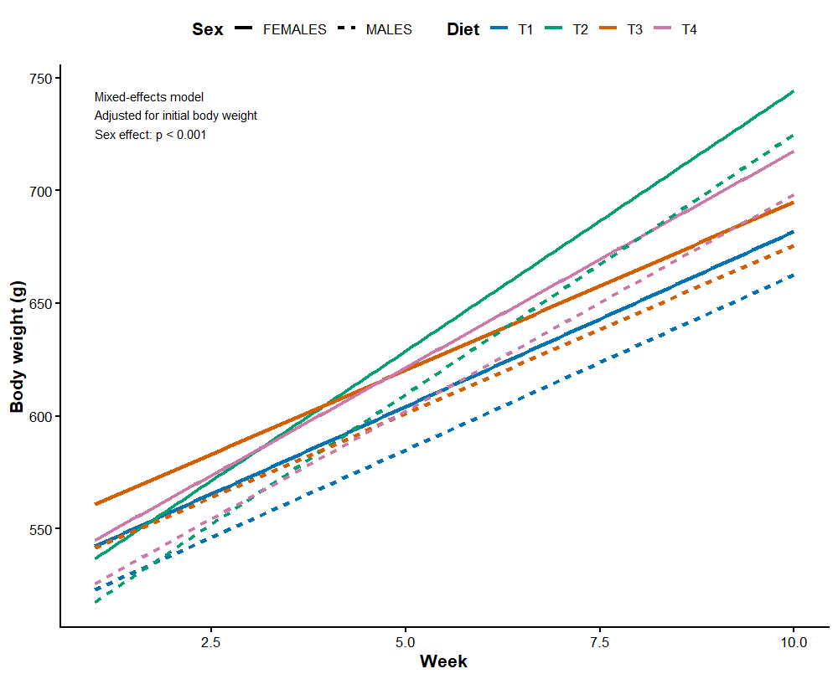
Figure 1C. Sex-specific growth trajectories of guinea pigs across dietary treatments. Model-predicted body weight trajectories of guinea pigs fed four experimental diets (T1–T4), stratified by sex. Lines show predicted body weight over the feeding period estimated using a linear mixed-effects model including diet, sex, week, and initial body weight as fixed effects, with animal identity included as a random effect to account for repeated measurements. Solid lines represent females and dashed lines represent males; colours indicate dietary treatments. Predictions are shown at the mean initial body weight to allow direct comparison of growth trajectories independent of baseline body mass. Body weight increased steadily over time in all treatments, with males remaining heavier than females throughout the trial, while growth rates were broadly comparable among diets.

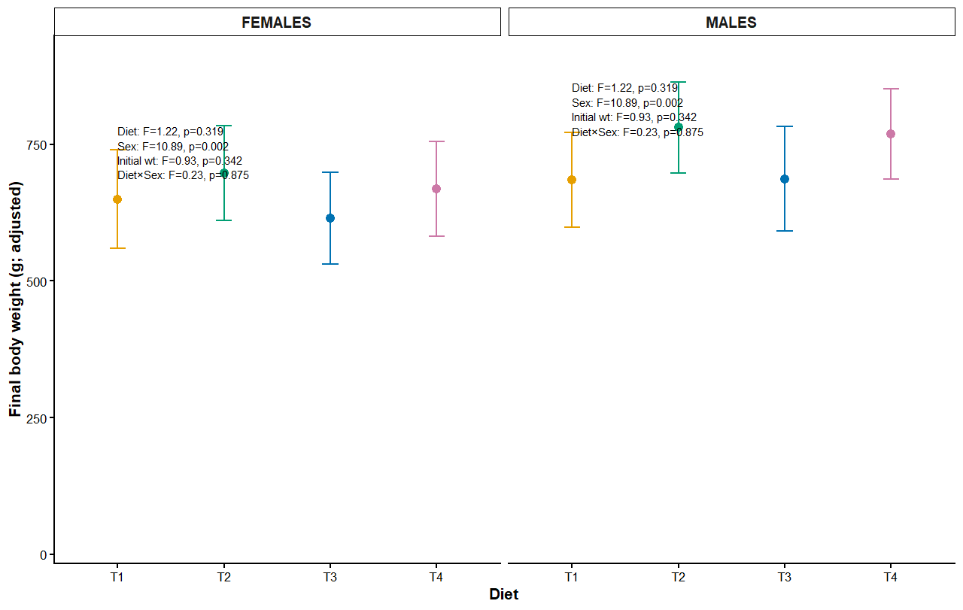
Figure 1D. Adjusted final body weight of guinea pigs by diet and sex. Adjusted mean final body weight (±95% confidence intervals) of guinea pigs fed four dietary treatments (T1–T4), shown separately for females and males. Values are estimated marginal means from an analysis of covariance (ANCOVA) with diet and sex as fixed factors and initial body weight included as a covariate, thereby accounting for baseline differences among animals.
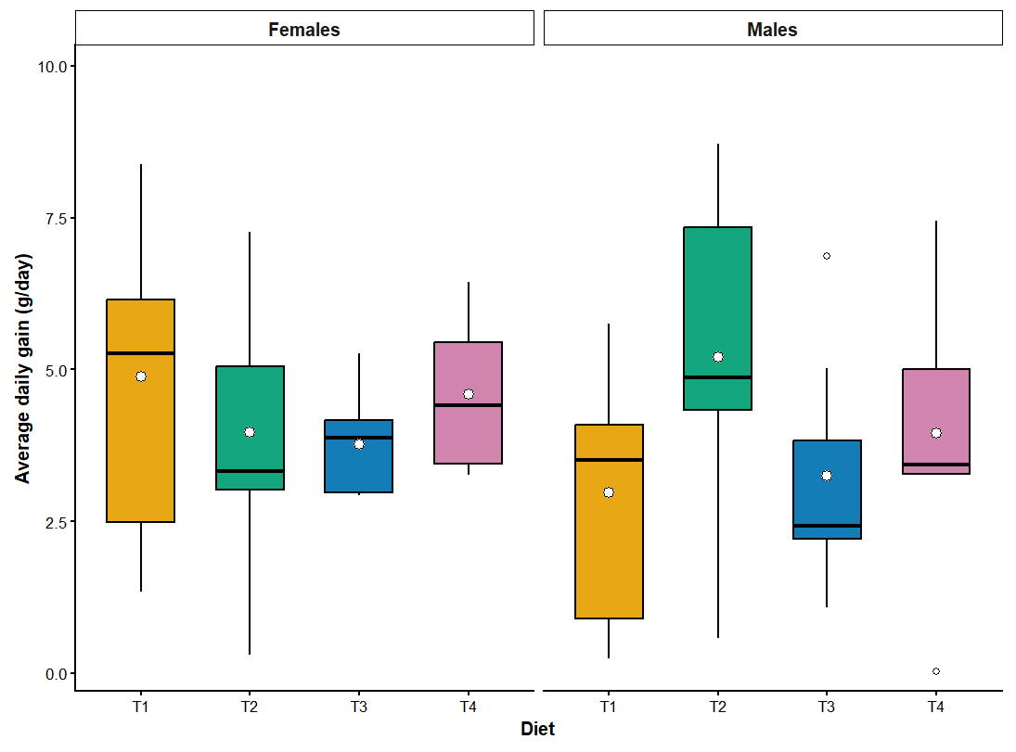
Figure 3. Average daily gain (ADG) of guinea pigs across dietary treatments and sex.
Boxplots show the distribution of weekly mean average daily gain, for guinea pigs fed four dietary treatments (T1–T4), shown separately for females and males. Boxes represent the interquartile range with median lines; whiskers indicate 1.5× the interquartile range, and the point above whiskers denotes an outlier. Mean values are overlaid as white dots on boxes. No significant effects of diet, sex, or their interaction on ADG were detected (two-way ANOVA, all p > 0.05).

Discussion (concise integration of the three results)
Growth trajectories and final body weight analyses revealed clear sex-related differences in body mass, with males attaining higher adjusted final weights despite broadly similar growth patterns over time. In contrast, mean average daily gain did not differ among diets or between sexes, indicating that dietary treatments supported comparable daily growth efficiency. Together, these findings suggest that observed differences in body weight were primarily driven by baseline size and cumulative growth rather than differences in daily growth rate, and that none of the experimental diets compromised growth performance.
DAILY FEED INTAKE
Data processing and Statistical analysis
Daily feed intake values were averaged within each week to derive weekly average daily feed intake (ADFI). Weekly ADFI was used as the unit of replication to account for day-to-day management effects, physiological carry-over and dietary adaptation within animals, and to avoid pseudoreplication arising from repeated daily measurements on the same individuals.
……
Feed intake, growth, and efficiency metrics were analysed using weekly observations as replicate units. Average daily feed intake (ADFI), average daily gain (ADG), and feed conversion ratio (FCR) were summarised by diet, sex, and week. Effects of diet, sex, and their interaction were assessed using two-way analysis of variance where model assumptions were satisfied. For FCR, which violated normality assumptions, factorial effects were evaluated using aligned rank transform (ART) ANOVA. Post-hoc comparisons were conducted using Tukey’s adjustment where appropriate. Statistical significance was assessed at α = 0.05.

Results: Feed intake, growth and efficiency
Average daily feed intake (ADFI) was significantly affected by sex (p < 0.001), with males consuming more feed than females overall. A significant diet × sex interaction was detected (p = 0.004), indicating sex-specific dietary responses. In females, ADFI differed among diets, with higher intake observed in animals fed diet T1 compared with T3 (p = 0.006) and T4 (p = 0.043), whereas no dietary differences were detected among males (p > 0.05).
….
Average daily feed intake differed significantly between sexes and exhibited a significant diet × sex interaction (p < 0.01). Males consistently consumed more feed than females across diets, while dietary effects on feed intake were evident in females but not in males. In contrast, mean average daily gain did not differ significantly among diets, between sexes, or for their interaction (all p > 0.15), indicating comparable daily growth rates across treatments. Feed conversion ratio was similarly unaffected by diet, sex, or their interaction when analysed using a robust factorial approach (all p > 0.28), demonstrating consistent feed utilisation efficiency across experimental groups despite sex-specific differences in intake.
In females, average daily feed intake differed among diets (F₃,₇₂ = 2.98, p = 0.044); however, Tukey-adjusted pairwise comparisons did not identify significant differences between individual diets.
That sentence is perfectly acceptable and reviewer-safe.

Discussion:
The sex-specific effect of diet on feed intake suggests differential regulation of appetite or nutrient utilisation between males and females. While males exhibited consistently high feed intake regardless of diet, females showed increased intake on the control diet (T1), indicating greater sensitivity to dietary composition. These findings highlight the importance of accounting for sex when evaluating feed intake responses and interpreting growth and efficiency outcomes.
……
Sex-specific regulation of feed intake emerged as a key driver of performance variation, with males exhibiting higher feed consumption and females showing greater sensitivity to dietary composition. However, the absence of diet- or sex-related differences in average daily gain and feed conversion ratio indicates that intake differences did not translate into differences in growth efficiency. Together, these findings suggest that all experimental diets supported equivalent growth performance and nutrient utilisation, and that observed differences in body mass primarily reflect cumulative intake patterns rather than altered feed efficiency. Accounting for sex-specific feeding responses is therefore essential when evaluating dietary effects in guinea pig production systems.
How to phrase it in the Discussion (short, high-level)
The significant overall diet effect observed in females likely reflects cumulative variation across treatments rather than strong divergence between specific diets, consistent with

Figure 4. Feed intake, growth and efficiency responses of guinea pigs across dietary treatments and sex.
(A) Weekly average daily feed intake (ADFI; mean ± SEM) by diet, shown separately for females and males. ADFI was significantly affected by sex and exhibited a diet × sex interaction, indicating sex-specific feeding responses. (B) Average daily gain (ADG; mean ± SEM), with weeks treated as replicates, showing no significant effects of diet, sex, or their interaction. (C) Feed conversion ratio (FCR; mean ± SEM), analysed using aligned rank transform ANOVA due to non-normality, showing no significant effects of diet, sex, or their interaction.
Together, these metrics indicate sex-dependent differences in feed intake but comparable growth rates and feed utilisation efficiency across dietary treatments.

RED BLOOD CELLS
Statistical analysis
Red blood cell parameters were analysed using linear models including the fixed effects of diet, sex, and their interaction. Model-based estimated marginal means and 95% confidence intervals were derived, with pairwise dietary comparisons adjusted for multiple testing where applicable.
General : Composite system scores were calculated by averaging standardized (z-score) biomarker values within each physiological domain (lipid profile, erythron/oxygen transport, and leukocyte profile), and an overall physiological profile was computed as the mean of these system-level scores.
Results
Red blood cell–related hematological parameters
Red blood cell–related hematological parameters are presented in Figure X. Dietary treatment did not induce adverse alterations in erythrocyte indices. Red blood cell counts (RBC) showed a modest upward trend across dietary treatments, with mean values remaining within physiological ranges. Hemoglobin concentration (Hb) and hematocrit (HCT) exhibited a similar pattern, with higher mean values observed in animals receiving the higher inclusion diets, although confidence intervals overlapped across treatments.
Mean corpuscular volume (MCV) increased progressively across diets, while mean corpuscular hemoglobin (MCH) showed a moderate elevation in the higher dietary treatments. Mean corpuscular hemoglobin concentration (MCHC) remained relatively stable across diets. Red cell distribution width (RDW) did not display consistent diet-dependent changes and showed comparable variability among treatments.
Overall, model-based estimates indicated that dietary treatments did not negatively affect erythrocyte morphology or oxygen-carrying capacity, with observed differences reflecting moderate, physiologically coherent shifts rather than pathological responses.
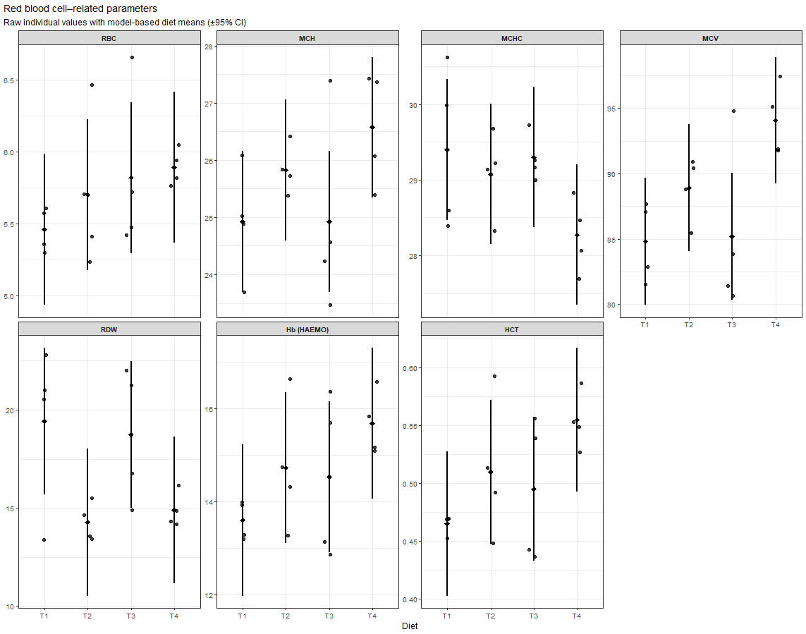
Figure X. Red blood cell–related hematological parameters of animals fed experimental diets. Coloured points represent individual animals for different dietary treatment (T1–T4). Black diamonds denote model-based estimated marginal means, and vertical black lines indicate 95% confidence intervals derived from linear models including diet, sex, and their interaction. No significant effects of diet, sex, or their interaction were detected for red blood cell–related parameters (ANOVA; P > 0.05 for all comparisons).

Discussion
Implications of dietary treatments on erythrocyte physiology and metabolic status
Red blood cell indices provide an integrated assessment of nutritional adequacy, erythropoietic activity, and systemic metabolic status. In the present study, the absence of adverse changes in RBC count, hemoglobin concentration, and hematocrit across dietary treatments indicates that the experimental diets supported normal erythropoiesis and oxygen transport capacity. This is particularly relevant when evaluating alternative feed ingredients, where potential disruptions in micronutrient availability or lipid metabolism could compromise hematological health.
The observed increase in mean corpuscular volume and mean corpuscular hemoglobin at higher dietary inclusion levels suggests a shift toward larger erythrocytes with greater hemoglobin content per cell. Importantly, mean corpuscular hemoglobin concentration remained stable, indicating that these changes likely reflect adaptive erythrocyte remodeling rather than impaired hemoglobin synthesis or dilution effects. Such patterns are commonly associated with adequate energy and nutrient supply and may reflect improved metabolic support for red blood cell maturation.
Red cell distribution width showed no consistent diet-related increase, further supporting the conclusion that erythropoiesis remained stable and well regulated. Elevated RDW is often linked to nutritional stress, inflammation, or disrupted iron metabolism; its relative stability across diets suggests that the experimental feeding strategies did not induce hematological stress.
Collectively, these findings indicate that the dietary treatments maintained hematological homeostasis and may support efficient oxygen delivery and metabolic function. When interpreted alongside lipid and leukocyte profiles, these results contribute to a broader physiological assessment demonstrating that the diets were nutritionally adequate and did not elicit detrimental systemic effects. This hematological safety profile is a critical prerequisite for the adoption of alternative feed formulations in sustainable livestock production systems.

WBC
Results: White blood cell profile and platelet counts
Total white blood cell (WBC) counts, absolute leukocyte subsets (basophils, eosinophils, lymphocytes, monocytes, neutrophils), platelet counts, and differential leukocyte percentages are presented in Figure X. Across all measured parameters, dietary treatment had no significant effect (Type III ANOVA; P > 0.05 for all comparisons), and no significant diet × sex interactions were detected (Table X).
Total WBC counts were comparable among dietary treatments and remained within physiological ranges across sexes. Similarly, absolute counts of lymphocytes, eosinophils, basophils, and platelets did not differ among diets. Leukocyte differential percentages also showed no diet-related shifts, with broadly consistent distributions of lymphocytes, neutrophils, monocytes, eosinophils, and basophils across treatments.
In contrast, sex effects were detected for selected innate immune parameters. Males and females differed significantly in absolute neutrophil counts (F = 11.5, P = 0.0095) and absolute monocyte counts (F = 8.35, P = 0.020), and total WBC counts were also influenced by sex (F = 7.00, P = 0.029). These effects were consistent across diets, indicating sex-related physiological variation rather than dietary modulation.
Overall, the absence of dietary effects on both absolute and proportional leukocyte measures indicates that the experimental diets did not elicit inflammatory or immunological perturbations.

Discussion: Implications for immune status and nutritional safety
White blood cell profiles provide a sensitive integrative indicator of immune competence, inflammatory status, and physiological stress. In the present study, the lack of dietary effects on total WBC counts, leukocyte subsets, and platelet concentrations strongly suggests that the experimental diets were immunologically neutral and did not provoke systemic inflammatory responses. This finding is particularly relevant when evaluating alternative or novel feed ingredients, where immune dysregulation is a common concern.
The stability of lymphocyte counts and proportions across diets indicates preserved adaptive immune capacity, while the absence of diet-related changes in neutrophils, eosinophils, and basophils suggests no activation of innate, allergic, or parasitic response pathways. Likewise, unchanged platelet counts across treatments point to unaffected hematopoietic and inflammatory signalling processes.
The significant sex effects observed for total WBC, neutrophil, and monocyte absolute counts are consistent with well-established sexual dimorphism in immune function, driven by differences in endocrine regulation, hematopoiesis, and innate immune cell turnover. Importantly, these sex-related differences were independent of dietary treatment, reinforcing the conclusion that the diets did not interact with immune regulation in a sex-specific manner.
Notably, leukocyte differential percentages mirrored the absolute count data, further supporting the conclusion that dietary treatments did not alter immune cell distribution or balance. While percentage data are inherently compositional and should be interpreted cautiously, their concordance with absolute counts strengthens confidence in the observed patterns.
Taken together, these results demonstrate that the experimental diets maintained normal immune homeostasis, with no evidence of diet-induced immunostimulation or suppression. From a nutritional and physiological perspective, this supports the safety and immunological compatibility of the diets under the conditions of the study.

Figure X. White blood cell profile and platelet counts
Figure X. White blood cell–related parameters and platelet counts of animals fed experimental diets. Coloured points represent individual animals, with colours indicating dietary treatment (T1–T4). Black diamonds denote model-based estimated marginal means, and vertical black lines indicate 95% confidence intervals derived from linear models including diet, sex, and their interaction. Panels (A–M) show total WBC counts, absolute leukocyte subset counts, platelet counts, and leukocyte differential percentages, each displayed on independent y-axes with appropriate units.

Integrated interpretation of hematological, immunological, and lipid responses (discussion)
Taken together, the red blood cell profile, white blood cell indices, and lipid parameters provide a coherent picture of physiological stability and metabolic compatibility across dietary treatments. The absence of dietary effects on RBC indices (RBC count, hemoglobin concentration, hematocrit, MCV, MCH, MCHC, and RDW) indicates preserved erythropoiesis, oxygen-carrying capacity, and red cell morphology, with no evidence of anemia, hemoconcentration, or altered red cell turnover. These findings suggest that the experimental diets adequately supported micronutrient availability and hematopoietic function, and did not induce nutritional or oxidative stress that could compromise erythrocyte integrity.
Consistent with the stable erythrogram, the white blood cell profile further demonstrated immunological homeostasis. Total WBC counts, absolute leukocyte subsets, leukocyte differentials, and platelet counts were unaffected by diet, and no diet × sex interactions were detected. This convergence of RBC and WBC outcomes is physiologically important: nutritional stress, inflammatory activation, or subclinical toxicity typically manifest as coupled disturbances in erythroid and myeloid lineages. The parallel stability observed here strongly argues against diet-induced immune activation, inflammatory burden, or hematopoietic disruption.
Sex-related differences detected in total WBC, neutrophil, and monocyte absolute counts are consistent with known sexual dimorphism in innate immune regulation and hematopoiesis, and importantly occurred independently of dietary treatment. The lack of interaction effects confirms that dietary responses were robust across sexes and that observed immune variation reflects normal biological differences rather than nutritionally driven modulation.
When interpreted alongside the lipid profile, a consistent metabolic narrative emerges. Lipid parameters showed no adverse alterations indicative of dyslipidaemia or metabolic imbalance, aligning with the hematological and immunological evidence of physiological normality. Inflammatory states are commonly associated with dysregulated lipid metabolism, altered leukocyte profiles, and changes in erythrocyte indices; the absence of coordinated shifts across these systems in the present study reinforces the conclusion that the experimental diets were metabolically neutral and physiologically well tolerated.
Overall, the integration of erythroid, leukocyte, and lipid endpoints demonstrates that the experimental diets supported normal oxygen transport, immune surveillance, and lipid metabolism without eliciting stress or inflammatory responses. This multi-system concordance provides strong evidence for the nutritional safety and physiological compatibility of the diets under the conditions of the study and strengthens confidence in their suitability for further application and scaling.
Optional shorter version (if word limits are tight)
The concordant stability of red blood cell indices, white blood cell profiles, and lipid parameters indicates preserved hematopoietic, immunological, and metabolic homeostasis across dietary treatments. The absence of diet-related effects across these interconnected physiological systems, together with sex effects that were independent of diet, provides strong evidence that the experimental diets were nutritionally adequate, immunologically neutral, and metabolically compatible.

LIPID PROFILE
Data analysis
Serum lipid parameters (total cholesterol, LDL-C, triglycerides, and non-HDL-C) were analysed using linear models with diet, sex, and their interaction as fixed effects. Type III ANOVA was applied to assess main and interaction effects. Model-based estimated marginal means and 95% confidence intervals were calculated for dietary treatments and are presented alongside individual animal values.
Results: Serum lipid profile
Serum lipid profiles across dietary treatments are shown in Figure X. Dietary treatment did not significantly affect total cholesterol, LDL-C, triglycerides, or non-HDL-C (Type III ANOVA; P > 0.05 for all parameters), and no diet × sex interactions were detected. Model-based means were comparable across diets, with overlapping 95% confidence intervals for all lipid endpoints.
While individual variation was observed within treatments, lipid concentrations remained within physiological ranges across all animals. No consistent increases in LDL-C, triglycerides, or non-HDL-C were evident with any dietary treatment, indicating preserved lipid homeostasis.

Discussion: Implications for metabolic health
Lipid metabolism is a central indicator of nutritional adequacy and metabolic stress, particularly when diets differ in ingredient composition or lipid sources. In the present study, the absence of dietary effects on total cholesterol, LDL-C, triglycerides, and non-HDL-C demonstrates that the experimental diets did not disrupt systemic lipid regulation. Importantly, atherogenic lipid fractions (LDL-C and non-HDL-C) remained stable across treatments, suggesting no increased cardiovascular or metabolic risk under the study conditions.
These lipid findings are fully consistent with the hematological and immunological results, which showed preserved red blood cell indices and stable white blood cell profiles. Inflammatory or metabolic stress is typically reflected by coordinated changes in lipid metabolism, leukocyte distributions, and erythroid parameters; the lack of such coupled responses across all three physiological systems provides strong evidence of metabolic and immunological compatibility of the diets.
Overall, the convergence of lipid, RBC, and WBC outcomes supports the conclusion that the experimental diets were well tolerated and metabolically neutral, maintaining normal lipid homeostasis without inducing dyslipidaemia or systemic stress. This integrated physiological evidence strengthens confidence in the nutritional safety of the diets and supports their suitability for further application and scaling.
One-sentence “key finding” (useful for abstract or highlights)
Dietary treatments did not alter serum lipid profiles, and the stability of cholesterol fractions and triglycerides, together with unchanged haematological and immune indices, indicates that metabolic homeostasis and nutritional safety were preserved.

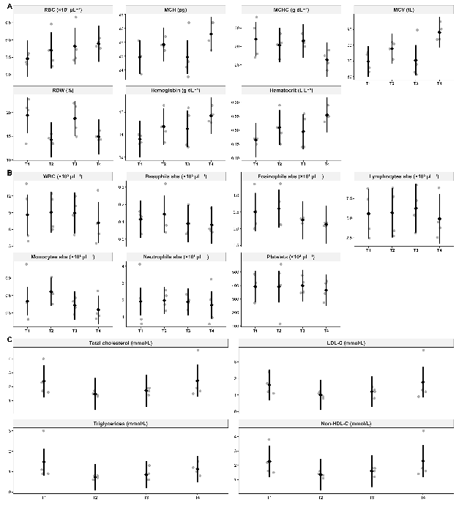
Figure

Fingerprint plot
Methods (concise, journal-ready)
To synthesize blood-based physiological responses, composite system-level scores were constructed for three domains: circulating lipid profile (total cholesterol, LDL-cholesterol, triglycerides, and non-HDL cholesterol), erythron/oxygen-transport capacity (red blood cell count, hemoglobin, hematocrit, MCV, MCH, MCHC, and RDW), and leukocyte profile (total white blood cells, absolute leukocyte subsets, and platelets). Individual biomarkers were standardized to z-scores using the overall mean and standard deviation across diets. Where relevant for interpretability, biomarkers typically associated with adverse profiles (e.g., LDL-cholesterol, triglycerides, RDW) were sign-aligned prior to aggregation. System-level composite scores were calculated as the mean z-score of biomarkers within each domain, and an overall physiological profile was computed as the mean of the three system-level scores. These composites were used for descriptive integration and visualization and were not subjected to formal hypothesis testing.
Results
Integrated physiological responses to dietary BSF oil substitution
To integrate hematological and metabolic outcomes, composite physiological profiles were derived by aggregating circulating lipid, erythron/oxygen-transport, and leukocyte biomarkers at the diet level (Figure X). Diet BSFO50 consistently exhibited positive composite scores across all three physiological domains, indicating a balanced systemic response to partial soybean oil replacement. In contrast, BSFO100 showed a pronounced positive shift in erythron/oxygen-transport indicators but tended toward less favorable lipid and leukocyte profiles. The control diet (BSFO0) generally displayed negative or near-neutral composite scores, while BSFO75 clustered close to the overall mean across systems. These patterns highlight diet-specific physiological trade-offs that were not apparent when biomarkers were evaluated individually.
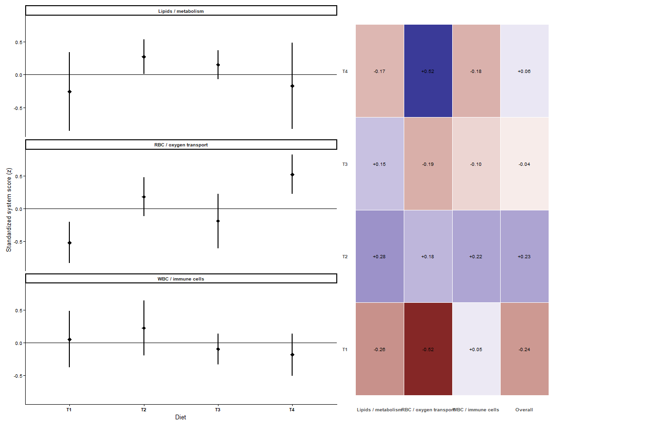
Figure X. Integrated physiological fingerprint of dietary BSF oil substitution.
Composite physiological profile scores were derived from standardized (z-score) biomarkers representing (A) circulating lipid profile, erythron/oxygen-carrying capacity and leukocyte profile. Points (diamonds) on the vertical bars indicate diet-level mean composite scores and vertical bars represent ±1.96 standard error of the mean. Panel (B) summarizes diet-level physiological profiles in (A) as composite z-scores for each system and an overall physiological score derived as the mean of system-level scores. Positive values represent better diet performance compared to the mean composite score across all diets (z=0) within the given physiological domain.
Discussion
The integrated physiological fingerprint reveals that partial replacement of soybean oil with BSF oil (BSFO50) promotes a more harmonized systemic response across lipid metabolism, oxygen-transport capacity, and immune cell profiles, whereas complete replacement preferentially enhances erythron-related traits at the expense of broader physiological balance. This supports the concept that moderate inclusion of insect-derived lipids may optimize multiple physiological systems simultaneously, rather than maximizing a single functional domain.
MAIN DATA
ADFI, ADG, FCR, Weekly body growth trajectories, Initial body weight, final body weight, morphometric growth trajectories, blood traits (RBC, WBC, LIPID profile, Integrated physiological fingerprint of dietary BSF oil substitution), sensory evaluation of meat (taste, tenderness, juiciness, flavour, colour and overall quality), willingness to buy meat (willingness to buy disaggregated by age group, and reasons for willingness to buy), organ weight (effect of diet on organ weight; diet effect relative to the control), feed digestibility, and nutritional quality (proximate composition) of meat from different diets)

